
COMPUTER SCIENCE AND ENGINEERING
Nov – 2026
ASSIGNMENT – 2
Course Code : CSA6303
Course Name : THREAT INTELLIGENCE AND NETWORK SECURITY
Student Name : L. Deepthi (192411213)
Max Marks: 50
Answer all the Questions
1 | The finance office of a university receives an e-mail that appears to come from the vice-chancellor's office, asking the accounts officer to open an attached "budget revision" document and to approve an urgent payment. The attachment contains a macro that installs a trojan, and within hours the finance file server is encrypted. Apply your knowledge of malware and phishing to this case. Explain the types of malware (virus, worm, trojan, ransomware, spyware, rootkit and botnet agent) with their method of spreading, and identify which types are involved here. Explain the types of phishing (bulk, spear phishing, whaling, smishing, vishing and clone phishing) and classify this attack with reasons. Prepare a table of the warning signs in the e-mail (sender address, header mismatch, urgency, link and attachment) and describe the technical controls (SPF, DKIM, DMARC, attachment sandboxing, macro blocking) and the awareness measures that would have stopped the attack. | (10) | (CO2) | (BL3)
2 | An online ticket-booking website sells tickets for a popular cricket match. Within seconds of the sale opening, its web servers become unreachable. The monitoring graph shows a very large rise in incoming traffic, thousands of half-open TCP connections, and many repeated requests for the search page from addresses all over the world. Analyse the incident by explaining how DoS and DDoS attacks differ, and the working of volumetric attacks (UDP flood and DNS or NTP amplification), protocol attacks (SYN flood) and application-layer attacks (HTTP flood), with the structure of the botnet that launches them. Explain how the security team can distinguish a DDoS attack from a genuine rush of customers. Recommend a response and prevention plan using rate limiting, SYN cookies, content delivery networks, traffic scrubbing, anycast and black-holing, and discuss the cost and side effects of each measure. | (10) | (CO2) | (BL4)
3 | Sales staff of a company often work from a café that offers free public Wi-Fi. A security audit finds that an attacker sitting in the café could create a fake access point with the same name as the café network, redirect users to a copy of the company's web mail login page, and capture the data that passes over the network. Analyse the attacks that make this possible by explaining the working of man-in-the-middle attacks, the evil-twin access point, ARP spoofing, DNS spoofing, IP and e-mail spoofing, SSL stripping and packet sniffing, with a labelled sequence or network diagram of one attack. Differentiate passive from active attacks in this case. Describe how each attack is detected (for example, duplicate MAC addresses in the ARP table, certificate warnings and IDS alerts) and prevented (VPN, HTTPS with HSTS, WPA3, dynamic ARP inspection, port security and 802.1X), and discuss which measures the company can apply to staff laptops it does not control. | (10) | (CO2) | (BL4)
4 | A small private clinic has a reception computer, two doctors' laptops, a patient-records server, a network printer, a Wi-Fi router and a few IP cameras on one flat network. The clinic has never tested its network for weaknesses. Apply the vulnerability assessment process to this network. Explain the steps of asset discovery, scanning (for example, with Nmap, Nessus or OpenVAS), identification of vulnerabilities, scoring with CVSS, prioritisation, reporting, remediation and re-scanning; the difference between authenticated and unauthenticated scans and between network-based and host-based scans; and the difference between a vulnerability assessment and a penetration test. Prepare a sample findings table with at least five realistic vulnerabilities of this clinic (for example, default router password, outdated operating system, unpatched server software, open remote desktop port and unencrypted camera streams), giving for each the affected asset, CVSS severity rating, possible attack and recommended remediation. | (10) | (CO2) | (BL3)
5 | The Security Operations Centre of a bank receives threat data from three kinds of sources: its own firewall, proxy and e-mail logs; free OSINT sources such as community threat-sharing platforms, malware-analysis sites, vulnerability databases and internet-scanning services; and a paid commercial feed. A new batch contains these entries: an IP address that was reported as malicious fourteen months ago, a domain that imitates the bank's login page and was reported yesterday, and a file hash that also matches a legitimate Windows utility. Evaluate the threat data sources and the quality of these entries. Compare internal, OSINT, community and commercial sources, explain the types of Indicators of Compromise (hashes, IP addresses, domains, URLs, e-mail artefacts, registry keys and file names) with the Pyramid of Pain, and judge each entry on timeliness, accuracy, relevance, context and the risk of false positives. Explain how feed formats such as STIX and TAXII help sharing, and recommend how the bank should select, integrate and retire . | (10) | (CO2) | (BL5)
NAME : L.DEEPTHI (192411213)
ANSWERS

Question 1 – Malware and phishing attack on a university finance office
The incident is a targeted email-based compromise. The message impersonates the vice-chancellor's office, pressures an accounts officer to open a document and approve a payment, and uses a malicious macro to install a trojan. The trojan then enables the attacker to deploy ransomware against the finance file server.

1. Malware types, spreading methods and relevance
Type | How it spreads / operates | In this case
Virus | Attaches to a legitimate file/program and spreads when the infected host file is run or shared. | Not established by the case; no file-infecting behaviour is stated.
Worm | Self-replicates and spreads between systems, often over networks, without needing a user to run each copy. | Not established; encryption of one server alone does not prove worm behaviour.
Trojan | Masquerades as a useful or expected file/software; executes malicious code after a user opens it. | Yes. The fake budget document/macro installs a trojan.
Ransomware | Encrypts or otherwise locks data and demands payment for restoration or non-disclosure. | Yes. The finance file server is encrypted.
Spyware | Secretly collects information such as credentials, browsing activity or documents and sends it to an operator. | Possible follow-on payload, but not stated in the scenario.
Rootkit | Hides malicious processes, files or privileged access to maintain stealthy control. | Not evidenced in the scenario.
Botnet agent | Malware that enrols a device into a remotely controlled group used for coordinated activity. | Not evidenced; the compromised server is not automatically a botnet member.

2. Phishing types and classification
Bulk phishing sends similar deceptive messages to many recipients. Spear phishing is tailored to a named person, team or organisation using relevant context. Whaling targets senior executives or other high-value leaders. Smishing uses SMS/text messages; vishing uses voice calls. Clone phishing copies a genuine earlier message and replaces its attachment or link with a malicious one.
Classification: this is spear phishing because it impersonates a specific university office and targets a finance employee with a payment-related request. It is not necessarily whaling: the recipient is an accounts officer, not a senior executive. It is not smishing or vishing because the delivery channel is email, and it is not shown to be clone phishing because no copied legitimate earlier email is described.

3. Email warning signs
Indicator | Warning sign | Safe action
Sender address | Display name may say 'Vice-Chancellor Office' but the actual domain may be misspelled, unrelated or a look-alike. | Check the full address and verify unusual requests through a known directory/phone number.
Header mismatch | Reply-To, Return-Path, sending domain or authentication results may not match the visible sender. | Inspect mail-security headers; quarantine or flag authentication failures and unexpected routing.
Urgency | Words such as 'urgent', 'today only' or 'approve immediately' discourage normal checks. | Treat pressure and secrecy as warning signs; use a second-person approval process.
Link | A link may lead to a look-alike login or file-sharing page; displayed text can hide its destination. | Hover/inspect destination without opening; use trusted bookmarks and URL filtering.
Attachment | Unexpected macro-enabled Office file, unusual extension or request to enable content. | Do not enable macros; scan and detonate attachments in an isolated sandbox.

4. Technical controls and awareness
- SPF (Sender Policy Framework): the domain owner publishes which mail servers may send mail for the domain. Receiving systems check whether the sending server is authorised. SPF helps detect forged envelope-sender domains, but does not by itself authenticate the visible display name.
- DKIM (DomainKeys Identified Mail): the sending system cryptographically signs selected message headers/body. The receiver checks the signature using the domain's published public key, helping verify message integrity and domain association.
- DMARC: tells receivers how to handle messages that fail aligned SPF and/or DKIM checks (monitor, quarantine or reject) and provides reporting. Correct deployment reduces direct domain impersonation.
- Attachment sandboxing: suspicious files are opened in an isolated environment and monitored for unexpected behaviour before delivery. It can identify macro activity and downloads, though sophisticated malware may evade analysis.
- Macro blocking: block macros from internet-originated Office files by default; allow only signed, approved macros from controlled trusted locations. Apply endpoint protection and least privilege.
- Awareness and process: train staff to inspect sender details, distrust urgent payment changes, verify requests through a separate known channel, report suspicious messages, and follow dual approval for payments. Run safe phishing-awareness exercises.
Conclusion: the most clearly identified malware are a trojan (initial delivery) and ransomware (impact). The attack is spear phishing. Layered email authentication, attachment controls, macro restrictions and independent payment verification could have interrupted the attack.
Question 2 – DDoS attack on an online cricket ticket website
The symptoms—large traffic growth, thousands of half-open TCP connections and repeated requests from globally distributed addresses—are consistent with a possible distributed denial-of-service (DDoS) incident. A real ticket launch can also create a sharp traffic spike, so the team should compare behaviour with expected customer patterns before blocking traffic.

1. DoS, DDoS and attack categories
A DoS attack attempts to make a service unavailable, commonly from one source or a small number of sources. A DDoS attack uses many distributed devices, often compromised bots, to overwhelm bandwidth, connection state, or application resources. The botnet may contain infected PCs, servers, routers, cameras and other IoT devices. A botmaster or command-and-control (C2) system coordinates bots; in some botnets, peer-to-peer control reduces dependence on one central server.
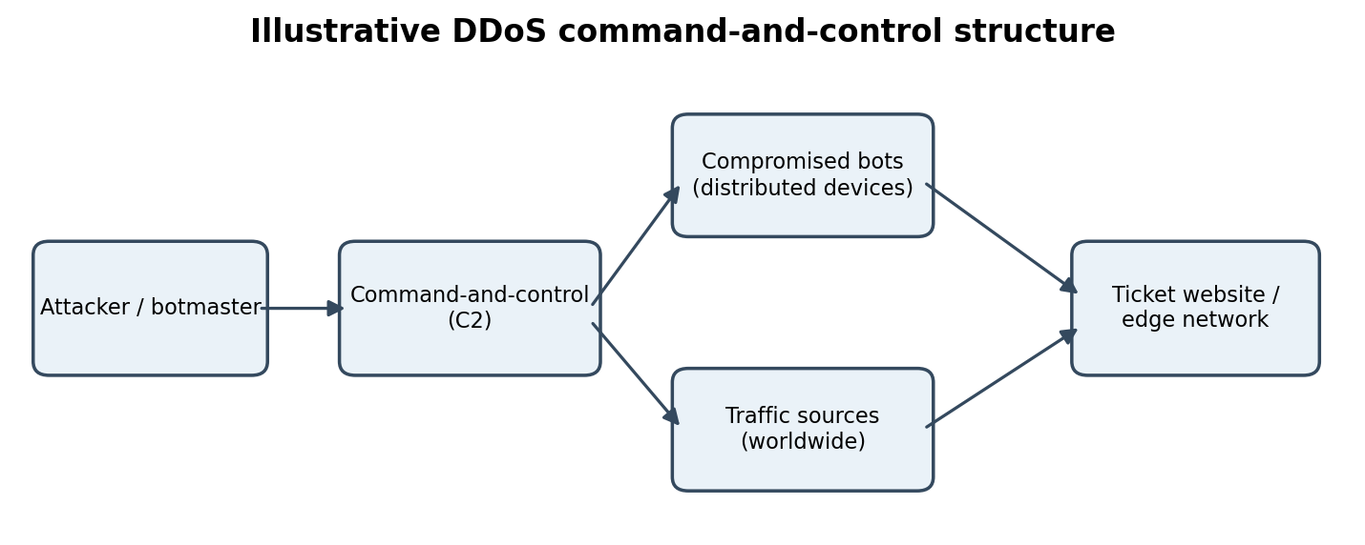

2. Main DDoS methods
Attack | Working | Possible evidence
Volumetric – UDP flood | Large volumes of UDP packets consume network bandwidth and packet-processing capacity. Some packets may target unused ports and cause reply traffic. | High bandwidth and packet rates; many destination ports or sources.
Volumetric – DNS/NTP amplification | An attacker abuses publicly reachable reflectors, sending small requests with a spoofed victim source address; reflectors send larger replies to the victim. | Inbound responses from many reflectors; traffic volume is disproportionate to the original requests.
Protocol – SYN flood | Large numbers of TCP SYN requests create half-open connection state; the server or network device spends resources waiting for completion. | High SYN count, many incomplete handshakes and elevated connection-state usage.
Application – HTTP flood | Many apparently valid HTTP requests consume web, search, database or application resources. Requests may be distributed and can resemble real users. | Repeated expensive URLs, abnormal request patterns, unusual session behaviour and high backend load.

3. DDoS versus genuine customer rush
- Compare traffic with ticket-launch forecasts, historical launches, marketing campaigns and the expected geographic/customer distribution.
- Examine request quality: genuine users usually show varied browsing paths, normal cookies/sessions and realistic think-time; automated floods may repeat the same endpoint or lack normal session progression.
- Correlate network, CDN, WAF, load-balancer, application and database metrics. A DDoS may produce high packet rates, half-open connections, abnormal error rates or resource exhaustion.
- Check source diversity and reputation, but do not treat foreign IP addresses or shared carrier/NAT addresses as proof of maliciousness.
- Use bot-management signals such as JavaScript execution, behavioural consistency and rate patterns carefully; avoid blocking accessibility tools or legitimate users.

4. Response and prevention plan with trade-offs
Measure | Purpose | Cost / side effects
Rate limiting / WAF | Limit requests per account, IP, token or endpoint; apply stricter controls to expensive search operations. | Low–medium cost; may throttle legitimate users behind shared NATs or during a genuine sale rush.
SYN cookies | Defer allocating full connection state until the TCP handshake is validated. | Usually low cost; protects against state exhaustion but does not solve bandwidth saturation or HTTP floods.
CDN / edge caching | Distribute static content and absorb/cache requests close to users; use bot controls at the edge. | Subscription and configuration cost; dynamic ticket inventory cannot always be cached and misconfiguration can affect availability.
Traffic scrubbing | Route suspicious traffic through a specialist service that filters attack packets before forwarding clean traffic. | Can be expensive and may add latency; requires provider coordination and pre-arranged activation.
Anycast | Advertise the same service IP from multiple network locations so traffic is distributed across sites. | Network/provider complexity and cost; does not remove attack traffic and can still overwhelm all sites or shared backends.
Black-holing | Discard traffic to a targeted destination when service preservation is impossible. | Fast but severe: legitimate traffic to that destination is also lost. Use only as a last resort with clear scope.
Recommended sequence: declare an incident; preserve logs; engage the ISP/CDN scrubbing provider; apply targeted rate limits and WAF rules; enable SYN protection; scale application capacity where safe; communicate service status; and review false positives. Use black-holing only if the attack threatens wider network stability.
Question 3 – Public Wi-Fi, evil-twin access point and man-in-the-middle attacks
The attacker can imitate the café's Wi-Fi name and persuade a laptop to connect to the rogue access point. If the user then visits a fake webmail page or accepts an invalid certificate, credentials or traffic may be exposed. Modern HTTPS with correct certificate validation prevents passive reading of protected sessions; the attacker may still observe metadata or attempt social engineering.

1. Attack concepts
Technique | Explanation
Man-in-the-middle (MitM) | Attacker positions themselves between two communicating parties and relays or alters traffic.
Evil twin | Rogue Wi-Fi access point copies a legitimate network name (SSID), attracting users to the attacker's network.
ARP spoofing | On a local IPv4 network, forged ARP messages associate an attacker's MAC address with another device's IP, potentially redirecting local traffic.
DNS spoofing | False DNS responses direct a user to an unintended IP address, often a look-alike site.
IP spoofing | A packet is sent with a forged source IP address; it can disguise origin but does not by itself establish a two-way session.
Email spoofing | The visible From address or related mail identity is forged to make a message appear to come from a trusted sender.
SSL stripping | An attacker attempts to downgrade a user's HTTPS connection to HTTP. HSTS and HTTPS-only policies help prevent this downgrade.
Packet sniffing | Capturing network packets to inspect traffic. On open or weakly protected networks, unencrypted content may be readable; encrypted payloads remain protected when TLS is correctly used.

2. Labelled attack sequence
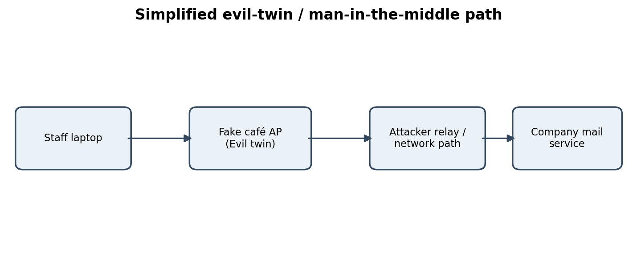
Sequence: (1) the laptop sees a familiar SSID and joins the rogue access point; (2) the attacker-controlled network relays traffic; (3) DNS or a deceptive link leads the user to a counterfeit mail login; (4) the user enters credentials; and (5) the attacker may reuse captured credentials. Valid HTTPS certificate checks, MFA and VPN reduce the chance and impact of compromise.

3. Passive versus active attacks
Passive attacks observe communications without changing them—for example, packet sniffing of unencrypted traffic. Active attacks alter, inject, redirect or disrupt communications—for example, ARP/DNS spoofing, an evil-twin access point used to redirect traffic, or SSL stripping. A single incident can combine both.

4. Detection and prevention
Threat | Detection | Prevention
Evil twin / rogue AP | Wireless IDS/monitoring can identify duplicate SSIDs, unexpected BSSIDs and unusual signal patterns; users may see unexpected captive portals. | Use trusted mobile hotspots where possible, WPA3-Enterprise/802.1X on company Wi-Fi, certificate-based authentication and user training.
ARP spoofing | Inspect ARP tables and network monitoring for conflicting IP-to-MAC mappings; IDS alerts can identify suspicious ARP behaviour. | Dynamic ARP Inspection (DAI), DHCP snooping and segmentation on managed switches.
DNS spoofing | Compare DNS answers with trusted resolvers; monitor unexpected DNS changes and certificate/domain mismatches. | Use trusted encrypted DNS where supported, DNS security controls and HTTPS certificate validation.
SSL stripping / sniffing | Browser certificate warnings, unexpected HTTP pages, IDS alerts and unusual proxy behaviour. | HTTPS everywhere, HSTS, VPN on untrusted networks, disable legacy protocols and never bypass certificate warnings.
IP / email spoofing | Review packet and mail headers, SPF/DKIM/DMARC results and gateway alerts. | Ingress/egress filtering, SPF, DKIM, DMARC and anti-phishing controls.

5. Controls for laptops the company does not own
- Provide a managed VPN client and require it for access to company systems on public Wi-Fi.
- Use conditional access, MFA, device certificates and browser/endpoint security where compatible.
- Provide a secure webmail portal with HTTPS/HSTS and phishing-resistant authentication where available.
- Give staff a short policy: avoid unknown Wi-Fi, prefer personal hotspots, do not ignore certificate warnings, and report suspicious login prompts.
- Where possible, offer a managed device or mobile-device-management enrolment. If personal devices cannot be centrally managed, rely on identity controls, VPN, browser protections and least-privilege access rather than assuming local firewall settings are enforced.
Note: WPA3, DAI, port security and 802.1X are mainly controls for networks the organisation administers. They cannot be directly imposed on a café's unmanaged access point or switch.

Question 4 – Vulnerability assessment of a small private clinic
The clinic should begin with written authorisation, a defined scope and a safe testing window. Patient-care systems must remain available, so scans should be coordinated with the clinic and performed with non-disruptive settings. Patient data should not be copied into reports unless essential.

1. Vulnerability assessment lifecycle
- Asset discovery: list reception PC, doctors' laptops, patient-records server, printer, router, switches, wireless devices and IP cameras. Record owner, OS/firmware, IP, business purpose and data sensitivity.
- Scanning: use approved tools such as Nmap for host/service discovery and Nessus or OpenVAS for known vulnerability checks. Scan only authorised addresses and avoid aggressive checks on fragile medical devices.
- Identification: correlate detected versions, exposed services, weak configurations and missing patches with vendor advisories and vulnerability databases. Manually validate important findings.
- CVSS scoring: use the CVSS base score and severity band as a technical starting point: Critical 9.0–10.0, High 7.0–8.9, Medium 4.0–6.9, Low 0.1–3.9. Environmental impact and exploitability may change priority.
- Prioritisation: consider patient safety, exposure to the internet, sensitive patient data, exploit availability, asset criticality and compensating controls—not CVSS alone.
- Reporting: document asset, evidence, risk, business impact, severity, remediation owner and target date. Separate confirmed findings from scanner false positives.
- Remediation and re-scan: patch, change defaults, close unnecessary services, segment networks and enforce encryption. Re-scan and verify that the weakness is fixed without disrupting clinical operations.

2. Scan types and testing approaches
Type | Meaning
Authenticated scan | Scanner uses approved credentials to inspect patch levels, local configuration and software inventory. Usually finds more local weaknesses; credentials must be protected.
Unauthenticated scan | Scanner tests from a network outsider's perspective without logging in. Shows exposed services and externally visible weaknesses but may miss internal patch/configuration details.
Network-based scan | Examines reachable hosts, ports, protocols and services across network segments. Useful for exposed services and network configuration.
Host-based scan | Runs an agent or local checks on a particular computer to inspect installed software, patches, permissions and configuration in greater depth.
Vulnerability assessment | Identifies and ranks potential weaknesses; generally broad and repeatable, with limited proof of exploitation.
Penetration test | An authorised, controlled attempt to validate whether selected weaknesses can be exploited and what impact could result. More intrusive and narrower in scope; requires stricter safeguards.

3. Sample clinic findings
The CVSS values below are illustrative estimates for a classroom case, not scores from a real scan. Exact scoring requires the affected product/version and CVSS vector.
Affected asset | Finding | Illustrative severity | Possible impact | Recommended remediation
Wi-Fi router | Default administrator password | High (example 8.1) | Unauthorised configuration changes; exposure of clinic network. | Set a unique strong admin password, disable remote administration, update firmware and restrict management access.
Reception PC | Unsupported/outdated operating system | High (example 8.1) | Known vulnerabilities may allow malware or unauthorised access. | Upgrade to a supported OS, enable automatic security updates and endpoint protection.
Patient-records server | Unpatched server/web application | Critical (example 9.1) | Remote compromise or access to confidential patient records, depending on the flaw. | Apply vendor patches after testing, remove unused components, back up and monitor.
Server / laptops | Remote Desktop exposed beyond required network | High (example 8.0) | Password guessing or exploitation may provide remote access. | Disable if unnecessary; otherwise restrict through VPN, MFA and firewall allow-listing.
IP cameras | Unencrypted video stream / weak credentials | Medium (example 6.5) | Unauthorised viewing or disclosure of camera feeds. | Change credentials, update firmware, use encrypted protocols and isolate cameras on a separate VLAN.
Printer | Unneeded management service exposed | Medium (example 5.3) | Device configuration exposure or misuse as a pivot point. | Disable unused services, update firmware and restrict printer management to administrators.

4. Suggested secure architecture
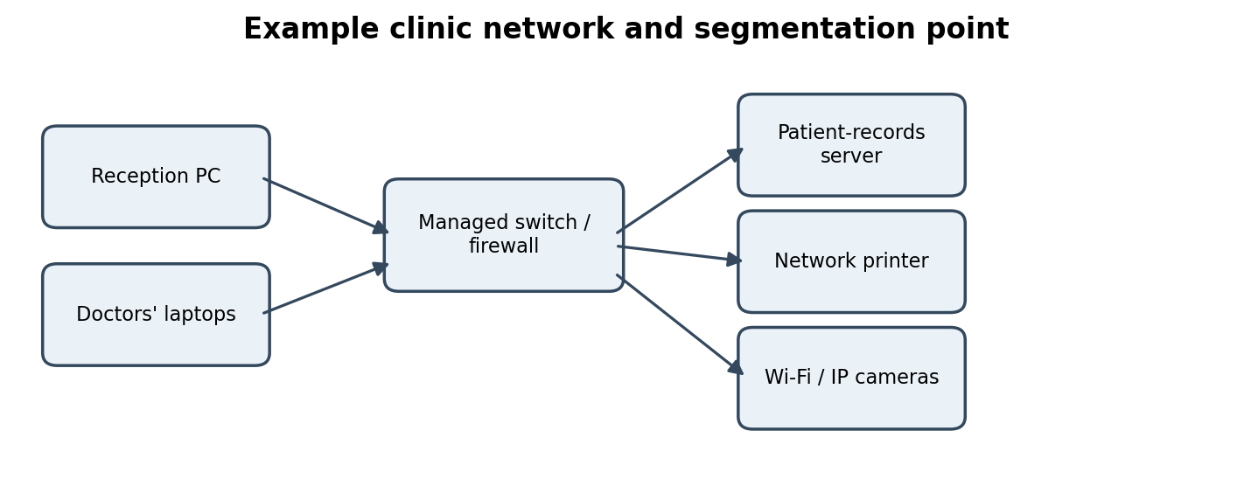
Place the patient-records server in a protected server VLAN; keep cameras and printers in separate device segments; allow only necessary traffic through the firewall; require VPN/MFA for remote administration; and maintain encrypted, tested backups. Apply least privilege and monitor access to patient records.
Question 5 – Threat-intelligence sources and IOC quality for a bank
The bank should not treat every feed item as equally trustworthy. Indicators must be validated, enriched with context, checked for age and false positives, and assigned an expiry/review date before they become SIEM rules.

1. Comparing threat-data sources
Source | Examples / strengths | Limitations
Internal telemetry | Firewall, proxy, endpoint, DNS and email logs; directly reflects the bank's environment. | High local relevance and context; may have blind spots and only show activity already observed.
OSINT | Public malware-analysis sites, vulnerability databases, scanning services and public reports. | Broad and often free; quality, freshness and completeness vary. Validate licensing and source reputation.
Community sharing | Peer organisations and information-sharing groups contribute sightings and analysis. | Useful operational context and rapid sharing; reports may be incomplete, duplicated or unverified.
Commercial feed | Vendor-curated intelligence, analyst research, reputation data and support. | May offer enrichment, SLAs and timely coverage; costs money and can still contain errors or overlap.

2. IOC types and Pyramid of Pain
Indicators of Compromise (IOCs) are observable clues that may indicate malicious activity. Common types include file hashes, IP addresses, domains, URLs, email artefacts (sender, subject, message ID or attachment details), registry keys and suspicious file names/paths. An IOC is evidence to investigate, not automatic proof of compromise.
IOC | Use and limitation
File hash | Exact fingerprint of a file; easy to share and match, but a small file change produces a different hash and benign files can be mislabelled.
IP address | Network endpoint associated with activity; can change, be shared by hosting providers or belong to a compromised legitimate host.
Domain | Internet name associated with infrastructure; useful for blocking and hunting, but ownership and hosting can change.
URL | Specific web resource; precise but can be short-lived and may contain legitimate shared-hosting components.
Email artefacts | Sender, reply-to, message ID, subject patterns and attachment indicators; useful for mail tracing and campaign clustering.
Registry keys / file names | Host artefacts useful for endpoint hunting; names can be changed and may be reused by legitimate software.
The Pyramid of Pain ranks indicators by how difficult they are for an adversary to change: hashes at the bottom; IP addresses; domain names; network/host artefacts and tools; and TTPs (tactics, techniques and procedures) near the top. Higher-level behaviours are generally more painful for an attacker to change, while hashes and IPs are often easy to replace. The pyramid is a prioritisation model, not a guarantee that every high-level indicator is accurate.

3. Evaluate the three supplied entries
Entry | Assessment | Recommended decision
IP reported malicious 14 months ago | Potentially stale; IP ownership and hosting may have changed. Accuracy and relevance are uncertain without recent sightings and context. | Low confidence until revalidated; do not permanently block solely on the old report. Check current reputation, ASN/hosting changes and internal observations; apply a short expiry if retained.
Look-alike bank login domain reported yesterday | Very recent and directly relevant to the bank; likely high priority if the report is verified and the domain truly imitates the bank. | Validate registration, DNS, page content, certificates and source credibility. Add to protective DNS/proxy/email controls and hunt for access; preserve evidence and notify takedown channels.
Hash also matches a legitimate Windows utility | High false-positive risk or ambiguous attribution; the hash may identify a legitimate signed file or a misclassified sample. | Do not block based on the feed alone. Verify exact hash algorithm, file signature, publisher, version and file provenance; compare with trusted software inventory and sandbox evidence.

4. Timeliness, accuracy, relevance, context and false positives
- Timeliness: record first-seen, last-seen and report dates. A recent report is not automatically true, and an old indicator may remain valid only if reconfirmed.
- Accuracy: consider source track record, corroborating sources, confidence rating and whether the indicator is directly observed or inferred.
- Relevance: relate the indicator to the bank's technology, geography, business services and current threat model.
- Context: retain the reason it was flagged, malware/campaign association, affected product, observation time, source, confidence and suggested action.
- False positives: check shared hosting, CDN addresses, cloud services, common software hashes and legitimate administrative tools before blocking.

5. STIX, TAXII and SIEM lifecycle
STIX (Structured Threat Information Expression) is a standard language for representing threat intelligence—such as indicators, threat actors, campaigns, malware and relationships—in a structured format. TAXII (Trusted Automated Exchange of Intelligence Information) is a protocol for exchanging that intelligence between systems. Together they make machine-readable sharing and integration easier, but do not guarantee that the information is correct.
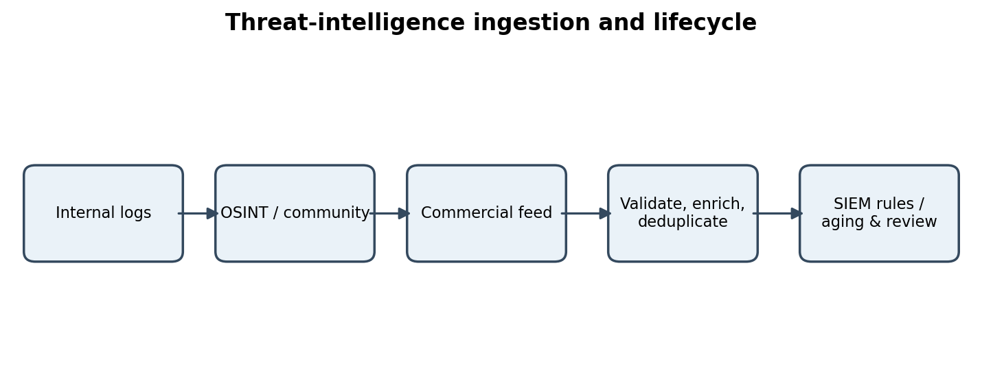
- Select feeds based on coverage, source transparency, update frequency, confidence metadata, permitted use, cost and relevance to the bank.
- Normalize indicators into a common schema; preserve source, timestamps, confidence, tags, relationships and expiry. Deduplicate identical indicators while retaining all source references.
- Enrich with internal sightings, passive DNS, WHOIS/registration data, malware analysis and business context. Validate high-impact indicators before automated blocking.
- Use graduated actions: low-confidence indicators may be used for alerting or hunting; high-confidence, current indicators may be blocked after impact review.
- Assign time-to-live (TTL) values by indicator type and confidence. Recheck old IPs/domains, expire stale items, and keep an audit trail of additions, changes and removals.
- Monitor SIEM rule performance, false-positive rates and analyst feedback. Retire indicators that are stale, disproven, duplicated or no longer relevant; retain historical records for investigations.
Conclusion: use a risk-based intelligence lifecycle. The recent look-alike domain deserves prompt validation and action; the 14-month-old IP needs rechecking; and the ambiguous Windows utility hash must not trigger an automatic block.

Quick revision summary
Question | Key points
Q1 | Trojan delivered through spear-phishing email; ransomware encrypts finance server. SPF/DKIM/DMARC, sandboxing, macro blocking and payment verification reduce risk.
Q2 | DDoS uses distributed sources; observed half-open TCP connections suggest SYN-flood activity, while repeated search requests may indicate HTTP flooding. Combine edge controls, rate limits and provider scrubbing.
Q3 | Evil twin can enable MitM. Protect sessions with VPN, HTTPS/HSTS, certificate validation and MFA; managed networks can add WPA3-Enterprise, 802.1X and DAI.
Q4 | Follow discover → scan → validate → score → prioritise → report → remediate → re-scan. Protect patient systems through segmentation, patching, strong credentials and backups.
Q5 | Assess IOC freshness, confidence, context and false-positive risk. Use STIX/TAXII for structured exchange and maintain SIEM deduplication, enrichment and expiry.

